**Dashboard reports**

**What are Dashboard Reports?**

Dashboard reports are reports that display project data is tabular and graphic form. Each report displays different data and can be customized to tailor the reports for each users needs.

Below is an example of the Overallocated Resources Dashboard Report. Note that there are 2 charts each representing different resource data. The chart on the left represents Actual work v Remaining Work. The chart on the right is displaying resources that are Overallocated at the day level. Each of these reports may be altered to adjust the chart type, chart elements and details of the display data.

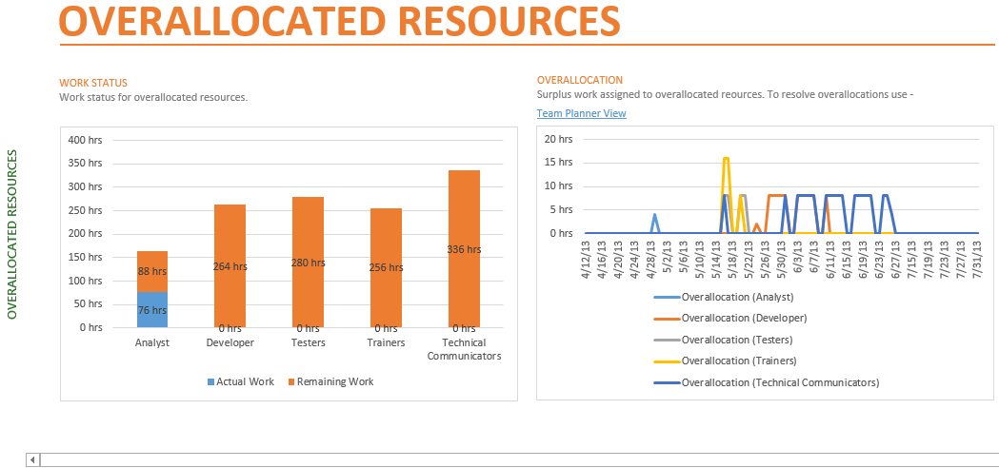

**Data included in the Dashboard Reports:**

Dashboard Reports contain data relating to project progress, variance calculations, and critical path. Below are listed some of the data which are included in the reports. If you are not using the data needed to populate the reports, the reports will not display properly.

Some of the data needed for the reports includes the following project data values:

* Task Duration, Cost and Work.
* Resource Cost and Work.
* Baseline comparison.
* Status date.
* Status field: Late, On Time, Future

See below for a list of the Dashboard Reports and the data which is represented on each report. Use this as a guide to decide which reports would be useful for you.

**Reports that come with MS Project 2013**

|  |  |  |
| --- | --- | --- |
| **Included in Reports section** | **Report Name** | **Data shown on report** |
|  |  |  |
| Dashboard | Burndown | 1) Remaining Cumulative Work v. Baseline Remaining Cumulative Work for active tasks; 2)  Number of tasks completed and number left to be completed |
|  | Cost overview | 1) Cumulative Percent Complete, Cumulative Cost; 2) Remaining Cost, Actual Cost and Baseline Cost; 3) Cost outline summary level 1 tasks |
|  | Project Overview | 1) Percentage complete of Outline level 1 tasks; 2) List of milestones and target dates; 3) Late tasks – tasks that are past due |
|  | Upcoming Tasks | 1) Work Percent complete is less than 100%, tasks starting within 5 days of system date; 2) Tasks starting soon list |
|  | Work Overview | 1) Remaining cumulative Work, Remaining Cumulative Actual Work, Baseline Remaining Cumulative Work; 2) Baseline work, actual work, remaining work at outline level 1; 3) Actual work v remaining work by resource and 4) Remaining availability by resource |
|  |  |  |
| Resources | Overallocated Resources | 1) Actual work v Remaining work; 2) Hours assigned to overallocated resources |
|  | Resource Overview | 1) Remaining work, Actual work, Baseline work; 2) Percent work completed by resource; 3) Remaining work assigned by resource |
|  |  |  |
| Costs | Cash flow | 1) Cost v Cumulative Cost, Cost Variance – Project Summary level; 2) Outline level 1 summaries Remaining cost, Actual Cost, Cost and Earned Value |
|  | Cost Overruns | 1) Task Cost Variance; 2) Resource Cost Variance |
|  | Earned Value Report | 1) Actual cost of work performed, Baseline cost of work performed, Baseline cost of work scheduled; 2) Cost Variance, Schedule Variance; 3) Cost Performance Index (CPI), Schedule Performance Index (SPI) |
|  | Resource Cost Overview | 1) Resource Remaining Cost, Actual Cost, Baseline Cost; 2) Cost distribution over resource types; 3) Cost details at the resource level |
|  | Task Cost Overview | 1) Cost status – Actual Cost, Remaining Cost, Baseline Cost; 2) Costs spread out amoungst tasks based on their status (On Schedule, Late, Future); 3) Cost Details – outlne level 1 |
|  |  |  |
| In Progress | Critical Tasks | 1) Chart – On Schedule, Late, Future 2) Table task level critical tasks |
|  | Late Tasks | 1) Chart – On Schedule, Late, Future; 2) Table task level – tasks that are late compared to status date. |
|  | Milestone Report | Late Milestones, Milestone up next and Completed Milestones |
|  | Slipping Tasks | 1) Remaining Cumulative Work, Remaining Cumulative Actual Work; 2) Task list for tasks where finish date are past the baseline finish date. |

**To Display a Dashboard Report:**

1. Click on the **REPORTS** tab
2. Click on a Report Category: **Dashboards, Resources, Costs, In Progress**
3. Click on a Report to display

To change parameter values displayed on a Dashboard Report:

1. Click on the **REPORTS** tab
2. Click on a Report Category: **Dashboards, Resources, Costs, In Progress**
3. Click on a Report to display
4. Click inside of a graph. Options will appear on the right side of the view.
5. Change options as necessary. Close by options by clicking on the X in the upper left corner of the options box.
6. Other changes may be made by clicking on formatting changes on the Design ribbon which will appear when a Report is selected.

**NOTE:** Changes to Dashboard Reports will be remembered within the file.

**TIP:** Clicking on the **Page Breaks** button will display the page breaks as for printing the report. The separate report graphics and tables may be dragged to different pages for printing purposes.